ETswap Introduction

ETswap Introduction：The innovative, safe and efficient liquidity protocol ETswap incubated by ETswapDao Labs is a decentralized exchange of automatic market making (AMM) based on the concept of capital pool. Driven by the DAO community, it proposes and implements multi chain swap models based on BSC, Ethereum, etc., integrates the respective advantages of multiple public chains, and supports the dual mining mechanism of liquidity pledge and transaction.

ETswap transaction fee：Platform transaction fee of 0.25%

The allocation rules are as follows:
The 0.17%LP Holder
Destroy the platform currency by 0.03% Put 0.03% into the Treasury
0.02%ETDR NFT dividend (ETDR NFT note: ETswap Platform Partner)
ET token contract mechanism: Initial contract: 0.8% rate
0.8% Rate Distribution:
The ET was destroyed at 0.3% ，0.2%ETDR NFT dividend
The 0.1%ETDR NFT repurchase fund
The 0.2%DAO community construction is conducted
Specific search white papers

ET Token Economics： Supply 1 billion Chain: BSC
① Donate 26%
Description: 16-month linear unlocking; 10% for the first month, 6% for the remaining month
Undonated Shares: Destroy

② Trading mining 20.2%
Description: 10 years linear unlock

③ Liquidity pledge pool 20%
Description: 10 years linear unlock

④ Community 15%
Description: 10-year linear unlock, DAO community contributors, marketing team incentive bonus, marketing

⑤ETswapDao Labs 5%
Description: 2-year cliff, 10-year linear unlock

⑥ Web3.0 Fund 5%
Description: 2 years cliff, 6 years linear unlock

⑦ Strategic cooperation 5%
Description: 1 year cliff, 6 years linear unlock

⑧ETswap liquidity 3%

⑨ Consultant 0.8%
Description: 1 year cliff, 6 years linear unlock

ET Token destruction mechanism： 0.03% of the ETswap transaction procedure and 0.2% of the initial ET Token transaction fee will be destroyed from time to time.

Staking and trading dual mining mechanism：1.LP pledge mining, pledge time period, 1 day, 10 days, 30 days, 180 days, 360 days, the larger the LP value and the longer the pledge period, the higher the mining income.
2.In transaction mining, ET Tokens are mined according to the transaction amount. The larger the transaction amount, the more ET Tokens are mined.

Marketing team incentive bonus：1. Earn 5% of the income of directly recommending LP pledge mining.
2. Earn 5% of the direct recommended transaction amount for mining.

Progress and Roadmap：2021 Q1 founding team formation
Q2 DAO community formation
Q3 ETswapDao Labs was established
Q4 ETswap White Paper Writing

2022 Q1 ETswap Framework Construction
Q2 ETswap R & D
Q3 ETswap BSC chain test online line
Q4 ETswap opens the donation
Q4 ETswap launches global marketing
Q4 ETswap1.0 BSC chain was officially launched, and the platform currency ET was launched for online trading

2023 Q1 ETswap ETH Chain Test Online Line
Q2 ETswap2.0 ETH chain is officially launched
Q3 cross-chain protocol research and development
Q4 Cross-chain protocol test online line

2024 Q1 ETswap3.0 cross-chain protocol was officially launched
Q2 ETswap Metaverse City Project Development
Q3 ETswap Metaverse Test online line
Q4 ETswap Metaverse global investment attraction

2025 Q1 ETswap4.0,Metaverse city officially opened

Beginner's Guide:
- Set Metamask Wallet:：
Installing MetamasK
If you have not installed MetaMask on your Chrome, Brave or Firefox browser, please install it from this link。
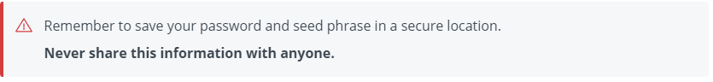
Connect Metamask to the BSC chain
1. Log in to MetaMask
2. In the upper-right corner of the page, select the Network drop-down menu.
3. Select Add Network
4. Continue to fill in the BSC network information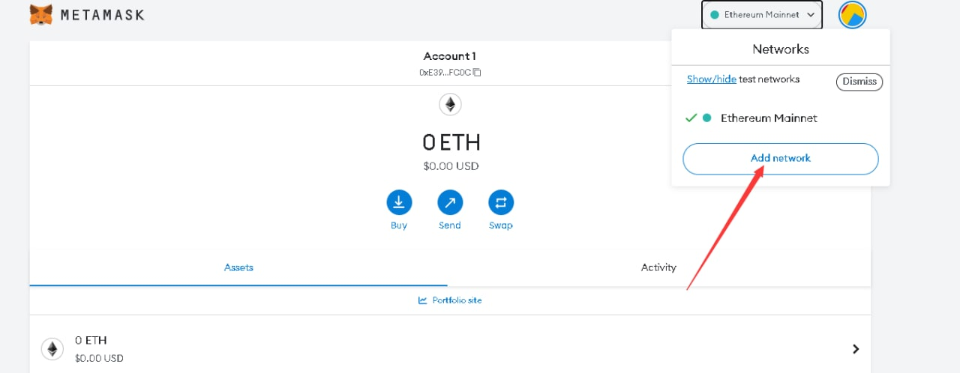
network name：Binance Smartchain
RPC URL：https://bsc-dataseed.binance.org/
ID：56
symbol：BNB
URL：https://www.bscscan.com/
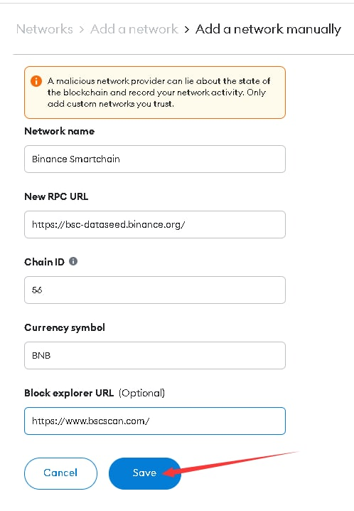

Add ET Compatible Token
After importing the token information, all your ET compatible tokens will be visible in this network.
1. Navigate to the bottom of the BSC Network page in MetaMask and select Import Token.
2. Enter the information for the token you wish to import
3. The token information is usually populated automatically. Always double check the token contract address to make sure it is not a fake version.
4. Select Add custom token to save.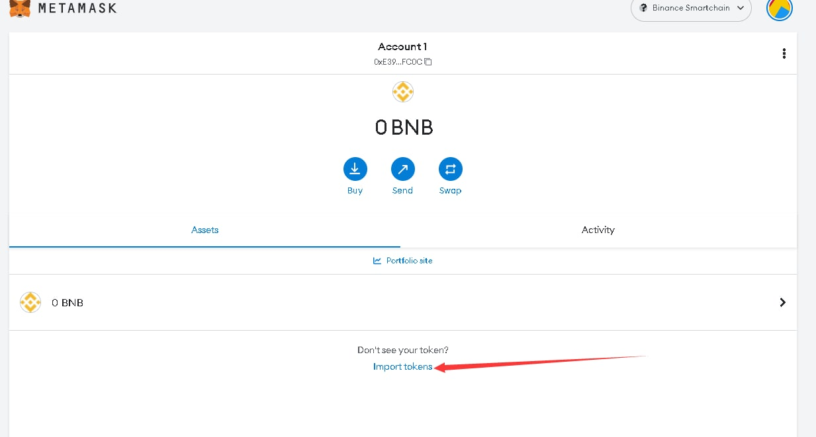
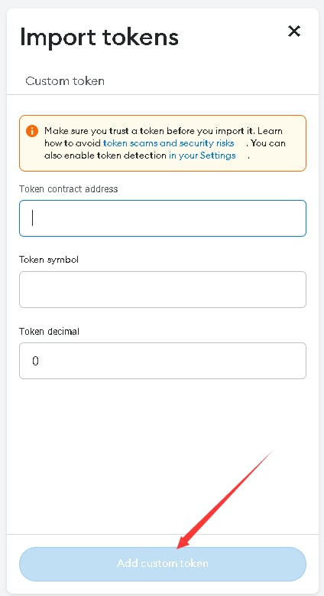
IMPORTANT: To use the BSC chain, you must have $BNB for transaction gas fees.

ETswap Bug Bounty Program：Bug bounties support developers and security engineers who examine ETswap code and products, and harden it against potential attack vectors now and in the future.
Program Rules

Please provide detailed reports with reproducible steps. If the report is not detailed enough to reproduce the issue, the issue will not be eligible for a reward.

Submit one vulnerability per report, unless you need to chain vulnerabilities to provide impact.

When duplicates occur, we only award the first report that was received (provided that it can be fully reproduced).

Multiple vulnerabilities caused by one underlying issue will be awarded one bounty.

Social engineering (e.g. phishing, vishing, smishing) is prohibited.

Make a good faith effort to avoid privacy violations, destruction of data, and interruption or degradation of our service. Only interact with accounts you own or with explicit permission of the account holder.

Out of Scope Vulnerabilities
When reporting vulnerabilities, please consider (1) attack scenario / exploitability, and (2) security impact of the bug. The following issues are considered out of scope:

Mentions of secrets, access tokens, API keys, private keys, etc. in Github, will be considered out of scope without proof that they are in-use in production

Any repository outside the clover-network Github organization

Issues/bugs/vulnerabilities specific to the given blockchain node client (e.g. Geth or Parity)

OS-related vulnerabilities

Clickjacking on pages with no sensitive actions.

Unauthenticated/logout/login CSRF.

Attacks requiring MITM or physical access to a user's device.

Previously known vulnerable libraries without a working Proof of Concept.

Comma Separated Values (CSV) injection without demonstrating a vulnerability.

Missing best practices in SSL/TLS configuration.

Email or DNS configurations

Site or domain configuration

Any activity that could lead to the disruption of our service (DoS; please set up POCs on a private chain).

Executing brute force attempts to perform actions beyond a proof of concept

Content spoofing and text injection issues without showing an attack vector/without being able to modify HTML/CSS

Disclosure Policy

Please do not discuss this program or any vulnerabilities (even resolved ones) outside of the program without express consent from the organization.

Safe Harbor
Any activities conducted in a manner consistent with this policy will be considered authorized conduct and we will not initiate legal action against you. If legal action is initiated by a third party against you in connection with activities conducted under this policy, we will take steps to make it known that your actions were conducted in compliance with this policy.
To report a bug and be qualified for the bug bounty program, please send a email to etswapdao@gmail.com

LOGO: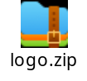
official channel: Twitter@ETswapDao
community channel：telegraph：https://t.me/ETswapDaoLabs
Discord：https://discord.gg/etswapdao
ETswap white paper：

